**Assignment 4 : Create Stored procedure in Northwind database to insert or update a**

**record in a table**

**--------------------------------------------------------------------------------------------------------------------------**

**1. Create a stored procedure in the Northwind database that will calculate the average**

**value of Freight for a specified customer.Then, a business rule will be added that will**

**be triggered before every Update and Insert command in the Orders controller,and**

**will use the stored procedure to verify that the Freight does not exceed the average**

**freight. If it does, a message will be displayed and the command will be cancelled.**

CREATE PROCEDURE spInsertInOrdersDEV

@customerID nchar(5),

@EmployeeID int,

@OrderDate datetime,

@RequiredDate datetime,

@ShippedDate datetime,

@ShipVia int,

@Freight money,

@ShipName nvarchar(40),

@ShipAddress nvarchar(60),

@ShipCity nvarchar(15),

@ShipRegion nvarchar(15),

@ShipPostal nvarchar(10),

@ShipCountry nvarchar(15),

@type nchar(10)

as

begin

if @type = 'insert'

if @Freight < (select avg(Freight) from Orders)

INSERT INTO Orders VALUES (@customerID ,@EmployeeID ,@OrderDate ,@RequiredDate ,@ShippedDate ,@ShipVia ,@Freight ,@ShipName ,@ShipAddress ,@ShipCity ,@ShipRegion ,@ShipPostal ,@ShipCountry )

else

print 'Given Freight Value exceeding the average Freight Value'

else if @type = 'update'

if @Freight < (select avg(Freight) from Orders)

update Orders set Freight = @Freight where CustomerID = @customerID and OrderDate = @OrderDate

else

print 'Given Freight Value exceeding the average Freight Value'

end

exec spInsertInOrdersDEV 'OTTIK',8,'2023-02-14 00:00:00:000','2023-02-16 00:00:00:000','2023-02-16 00:00:00:000',3,70,'Harmony','LDRP - ITR','Gandhinagar',NULL,382016,'india','insert'

exec spInsertInOrdersDEV 'OTTIK',8,'2023-02-14 00:00:00:000','2023-02-16 00:00:00:000','2023-02-16 00:00:00:000',3,68,'Harmony','LDRP - ITR','Gandhinagar',NULL,382016,'india','update'

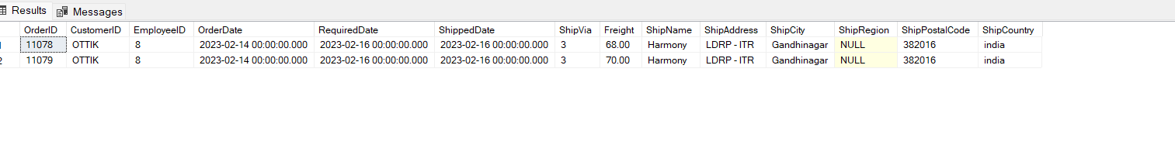

**2. write a SQL query to Create Stored procedure in the Northwind database to retrieve**

**Employee Sales by Country**

CREATE procedure salesbycountry

@country nchar(50)

AS

BEGIN

SELECT e.FirstName ,e.LastName,o.ShipCountry,os.Subtotal AS SALES from Employees e LEFT join Orders o on e.EmployeeID=o.EmployeeID RIGHT join [Order Subtotals] os on o.OrderID=os.OrderID Where shipcountry=@country group by e.FirstName ,e.LastName,o.ShipCountry,os.Subtotal

END

drop proc salesbycountry

EXEC salesbycountry 'argentina'

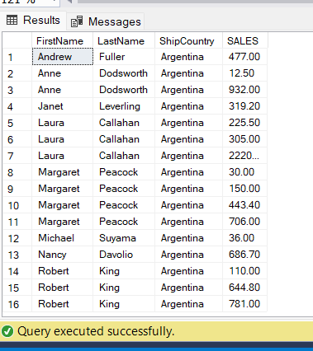

**3. write a SQL query to Create Stored procedure in the Northwind database to retrieve**

**Sales by Year**

CREATE procedure salesbyYeardev

AS

BEGIN

SELECT o.OrderID,year(o.ShippedDate) AS year,os.Subtotal AS SALES from Orders o join [Order Subtotals] os on o.OrderID=os.OrderID group by o.OrderID,year(o.ShippedDate),os.Subtotal

END

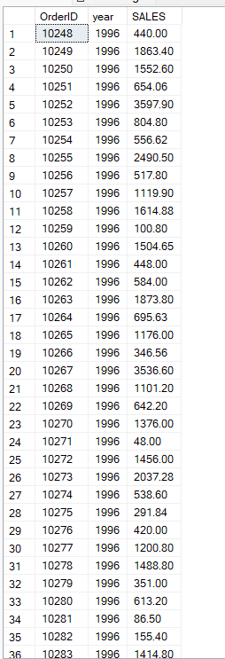

**4. write a SQL query to Create Stored procedure in the Northwind database to retrieve**

**Sales By Category**

CREATE procedure prSalesByCategory

@CategoryID int

as

begin

select c.CategoryID, c.CategoryName as [Category], count(o.OrderID) as [Total Orders] from Categories c

join Products p on c.CategoryID = p.CategoryID

join [Order Details] o on p.ProductID = o.ProductID

where c.CategoryID = @CategoryID

group by c.CategoryID, c.CategoryName

end

exec prSalesByCategory 1

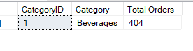

**5. write a SQL query to Create Stored procedure in the Northwind database to retrieve**

**Ten Most Expensive Products**

CREATE procedure sptop10expensiveproducts

AS

BEGIN

SELECT top 10 p.ProductName , p.UnitPrice from Products p group by UnitPrice,ProductName order by UnitPrice desc

End

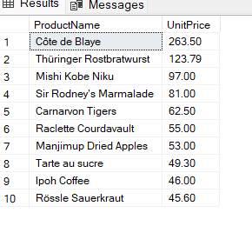

**6. write a SQL query to Create Stored procedure in the Northwind database to insert**

**Customer Order Details**

SELECT *from [Order Details]

CREATE PROCEDURE SPINSERTINTOORDERDETAILS

@OrderID INT,

@ProductID INT,

@Unitprice Float,

@Quantity int,

@Discount float

AS

BEGIN

INSERT INTO [Order Details] VALUES (@OrderID,@ProductID,@Unitprice,@Quantity ,@Discount )

END

EXEC SPINSERTINTOORDERDETAILS 10250,49,50.50,10,0

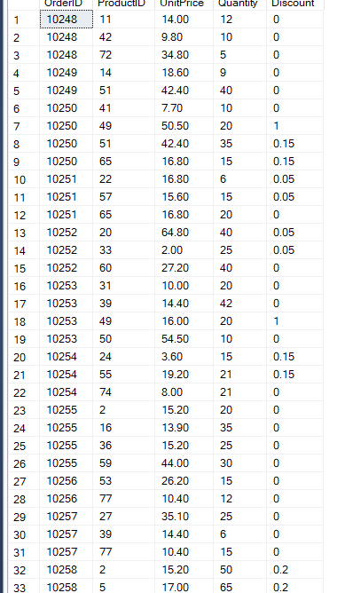

**7. write a SQL query to Create Stored procedure in the Northwind database to update**

**Customer Order Details**

CREATE PROCEDURE SPUpdatecustomerdetails

@ProductID INT,

@Quantity int,

@Discount float

AS

BEGIN

UPDATE [Order Details] SET Discount =@Discount ,Quantity=@Quantity where ProductID =@ProductID

END

EXEC SPUpdatecustomerdetails 49,20,1

